What is Crm?

CRM stands for **“Customer Relationship Management”** and refers to all strategies, techniques, tools, and technologies used by enterprises for developing, retaining and acquiring customers.

This software ensures that every step of the interaction with consumers goes smoothly and efficiently in order to increase the overall profits. The software gathers customer data from multiple channels. Hence, CRM stores detailed information on overall purchase history, personal info, and even purchasing behavior patterns.

**WHOCANBENEFITFROMCRM?**

The best part about a CRM system is that almost any organizational unit can benefit from it — from sales and customer service to recruiting, marketing, and business development. Good CRM software gives a better way to manage external relationships.

Storing all customer information in one place, recording service issues, identifying sales opportunities, managing marketing campaigns — these are just a few capabilities that **CRM features**.

Since CRM provides easy access to data, it also becomes much easier for users to collaborate on different processes and increase productivity. Another strong argument in favor of CRM is that it is suitable for businesses of any size.

## WHAT ARE THE TYPES OF CRM SYSTEMS?

### ON-PREMISECRMVSCLOUD-BASEDCRM

Companies carefully consider the way they deploy CRM system to make sure it needs their business objectives. While some organizations may benefit from on-premise software, there are many advantages of a cloud CRM deployment.

With on-premise CRM, a company needs to purchase the licenses beforehand. Considering that the software is located on the company’s servers, on-premise CRM is a good choice for organizations with a strict security policy, but in such a case, the implementation process takes more time and IT resources. Though, it is buyer’s task to ensure the constant maintenance of on-premise system, as vendor has no responsibility for its flawless operation and data security after the implementation stage, the vendors still provide technical support who will deal with the critical issues.

### CLOUD-BASEDCRM

On the other hand, software-as-a-service (SaaS), cloud or on-demand CRM, stores data on the vendor’s servers. In this case, the users have the full access to the database all the time wherever they are, and, most importantly, the vendor takes all the responsibility for the seamless operation of the system and provides all the necessary system updates and support.

What’s important is that cloud-based CRM software is highly scalable, which means that an organization can easily expand its functionality when business requirements grow.

The only requirement for cloud system accessibility is a strong internet connection, accompanied by an affordable monthly or annual fee.

## 11 ways CRM can benefit your business

A CRM solution can be used in various ways and provide numerous benefits to your business. Here are 11 key benefits a CRM could provide.

### 1. Better customer service

Modern CRM software has many functions, but the software was created to

[improve business-customer relationships](https://www.businessnewsdaily.com/10058-crm-customer-service.html), and that's still its main benefit. A CRM

manages all of your contacts and gathers important customer information – like

demographics, purchase records and previous messages across all channels – and

makes it easily accessible to anyone in your company who needs it. This ensures that

your employees have all they need to know about the customer at their fingertips and

can provide a better customer experience, which tends to boost customer satisfaction.

### 2. Increased sales

A CRM tool can help you streamline your sales process, build a sales pipeline, automate key tasks and analyze all of your sales data in one centralized place, potentially increasing sales and productivity. A CRM helps you establish a step-by-step sales process that your employees can rely on every time and that you can easily tweak as issues arise.

### 3. Improved customer retention

Once you've procured and converted leads, it's vital that you put in the work to retain them as customers and promote customer loyalty. High customer turnover can have many negative effects for your business, like diminished revenue or disrupted cash flow, so use your CRM and the information it provides about your customers to encourage repeat business. The CRM will provide sentiment analysis, automated ticketing, customer support automation and user behavior tracking to help you determine problems and quickly address them with your customers.

### 4. Detailed analytics

It's one thing to have plenty of data about your customers, but you need to know what it means and how to use it. CRM software typically has built-in analytic capabilities to contextualize data, breaking it down into actionable items and easily understood metrics. Metrics such as click-through rates, bounce rates, and demographic information allow you to judge the success of a marketing campaign and optimize accordingly.

### 5. Higher productivity and efficiency

CRM software uses marketing automation technology, which expedites menial tasks

like [drip campaigns](https://www.businessnewsdaily.com/15859-how-to-create-email-drip-campaign.html) and frees up your employees' time to focus on work only

humanscan handle, like creating content. It can also ensure that no tasks slip through

the cracks (e.g., all important emails are always sent to the right people). Additionally,

a [CRM can show you a dashboard](https://www.businessnewsdaily.com/16069-crm-dashboard.html) of how your business processes are working and

where [your workflows could improve](https://www.businessnewsdaily.com/16023-crm-workflows.html).

### 6. Centralized database of information

Another thing CRM software does best is providing [a centralized database](https://www.businessnewsdaily.com/6358-big-data-solutions.html) with all

information on your customers, making it easily accessible to anyone in your company

who needs it. This makes it easy for a sales representative to see what products a

certain customer is interested in, for example. If the customer has previously interacted

with the company, the CRM will include records of that interaction, which can inform

future marketing efforts and sales pitches. This saves your employees the time of

digging through old files and records, and it makes for a better and more productive

experience for the customer.

### 7. Managed communications with prospective leads

[Lead nurturing](https://www.businessnewsdaily.com/10050-crm-software-terms.html) can be an arduous and complicated process, with many steps and opportunities to communicate. A CRM automatically manages the process, sending your employees alerts when they should reach out to the prospect and tracking every interaction, from emails to phone calls.

"One great advantage of [CRM] is that you can see your customer's journey holistically," said Michael Miller, CEO of [VPN Online](https://vpnonline.com/). "With every phase in the design and every email you sent out reviewed, you can quickly figure out the next move to make. It's like seeing it from the top view, and you can easily create a decision on what to do next."

### 8. Improved customer segmentation

A list of hundreds of contacts can be unwieldy and overwhelming. For example, how do you know which customers want to see your email about your new in-store product? A CRM will automatically segment your contact lists based on your criteria, making it easy to find the ones you want to contact at any given time. You can sort contacts by location, gender, age, buyer stage and more.

"Automation actually allows the marketer to have a more meaningful understanding of the customer and have more valuable interaction when they do interact because of it," Philips said. "The important part to understand about automation is that we don't want to write a general email to our customers. Instead, we want to send emails reflecting customers' preferences, interests and values by segmenting them into groups using the data gleaned within the CRM."

### 9. Automated sales reports

Your team can easily collect and organize data about prospective and current customers using the CRM software's dashboard and reporting features, which allow employees to automate and manage their pipelines and processes. The CRM can also help your team members evaluate their performance, track their quotas and goals, and check their progress on each of their projects at a glance.

### 10. More accurate sales forecasting

With any business operation, you need to be able to review your past performance and strategically plan for the future. Using the automated sales reports in CRM software,

you can identify key trends and get an idea of what to expect from your future sales cycle performance, while adjusting your goals and metrics to suit those projections.

### 11. Streamlined internal communications

Aside from facilitating communication between your business and your customers, a

CRM can make it easier for your employees to communicate with each other. A CRM

makes it easy to see how other employees are speaking with a potential customer,

which helps your team maintain a unified brand voice. It also allows team members to

send each other notes or alerts, tag each other on projects, and send messages and emails, all within one system.

## What companies can benefit from CRM?

Because CRM software provides such a breadth of benefits, many types of businesses and teams can benefit from it.

"Not all customers are created equal, so the value of a CRM is that it helps you keep the right customers and deploy your precious marketing dollars towards the customers that will return the highest value over their customer lifetime," said Mike Catania, CEO and co-founder of Locaris. "It is challenging for small businesses to identify and acquire customers, so bucketing them into optimal and suboptimal segments through CRM is inordinately valuable."

Businesses of all sizes, from solo freelancers to enterprise-level corporations, can use CRM technology effectively. After all, the [key functions of a CRM](https://www.businessnewsdaily.com/7838-choosing-crm-software.html) are organization, centralized task management, marketing automation, and communication, which are important to every business's success.

Of course, some businesses stand to gain more from the use of a CRM than others:

### Businesses with a dedicated sales team

where can improve your strategies, and automating menial tasks for your sales

representatives.

### Businesses with a marketing team

CRM and marketing go hand in hand. CRM data can help your marketing team identify, capture, nurture and convert leads; track customer-salesperson interactions; monitor drip campaigns within the sales cycle, and more. All of this can create a smoother and more consistent customer experience.

### Businesses seeking to increase efficiency

Because CRMs automate processes like contact organization and communication

, the software can significantly speed up everyday processes and tasks for your entire

team.

A CRM can also reduce errors and ensure that all communications go out to the right

people at the right time.

Salesforce Edition:(Lowest to Highest)

## Types of Salesforce Editions

There are five types of Salesforce Cloud Editions. These Editions are given below:

1. **Essentials Edition**
2. **Professional Edition**
3. **Enterprise Edition**
4. **Unlimited Edition**
5. **Developers Edition**

1. Essential Edition

Essential Edition is the basic edition designed for small businesses who want to run their business on the CRM system quickly. It provides the proper setup assistant to get started with the system to the users. It helps the user with the assistant of using the UI and various administration tools to customize the business applications. ***The pricing for the essential edition is $25 user/month.***

The essential edition provides the default features to fulfill the needs of direct sales. It includes the following features:

* Account, Contact, Lead Management, and Opportunity Management
* Mobile Access of Salesforce CRM
* Sales Process Automation with the help of Process Builder.
* Service Console Apps
* Case Management
* Lead Assignment and routing
* Duplicate blocking
* Customizable Sales process.

Functional Limitations of Essential Edition

* It does not allow the midsize and large businesses to customize the solution with the code.
* It has limited sales automation capabilities.
* Third-party system integration also not possible.
* It does not allow the features for the management of contracts, orders and quotes.
* Creation of user profiles, roles and permission sets are not possible in this edition.

2. Professional Edition

The professional edition is the advanced edition that is mainly designed for businesses that require more CRM functionalities, security, and customization. It provides easy to use customization tools. It also includes the integrations and administration tools to allow small or midsize application deployment. It means this is the first edition that allows the companies to perform any development work on it. It allows us to create the ***two user profiles per Org, two user roles per org, and permission sets***. But these are limited options for the mid-sized organization.

**The professional edition is well suited for mid-sized organizations with only one sales department with upto 60 team members.**

The pricing for the professional edition is **$75 per user/month.**

It contains the essential features, including with the following features:

* Lead Registration and Rule-based lead scoring
* Sales orders
* Products and price books
* Collaborative forecasting
* Case milestone tracker
* Store and manage any number of contacts
* Track sales opportunities
* Provides the Person accounts
* Sales console App
* Forecasting Mobile App
* Unlimited Custom Applications
* Developer Sandbox
* Lightning Sync

**Some Missing Features of professional editions are given below:**

* Salesforce Web Service API for development integration with third-party is possible, but it requires more than 25 USD per user/month.
* The enterprise Territory Management feature is also missing, which manages the group of accounts and sales reps as per the territorial criteria.
* Opportunity team and opportunity split features are missing, which are the two crucial features for the small-mid sized organizations.
* ***No access to Apex, Visualforce, Workflow Automation, approval access, custom profiles, and full sandbox.***

3. Enterprise Edition

The enterprise edition is designed to fulfill the requirement of large and complex businesses. It provides access to all platform's functionality, which includes the advanced tools for the customizations and administrations.

This edition enables the organization to access the [Salesforce](https://www.javatpoint.com/salesforce) APIs so that the developers can integrate the applications with the back-office systems.

***The pricing to access all the functionalities of EE is 150 USD per user/month***. It is one of the most popular salesforce editions among the companies that is most beneficial for the customers. Mostly the developers and administrators want to work with the enterprise edition, as it provides all the required functionality for the development and end-users.

It provides all the features of Profession edition, including the below features:

* Access to Apex and Visualforce
* Workflows and approval automation
* Product and Price books
* Sales Territory Management, accounts, and sales teams
* Offline access to the CRM
* Custom Opportunity Fields in Forecasting
* Opportunity Splits
* Web Service API with no additional Charge
* Unlimited Record Type
* Unlimited Roles and Permission
* Advanced Reporting Features.

4. Unlimited Edition

The unlimited edition maximizes business success and extends it across the entire enterprise through the Lightning Platform. It is the flagship solution for the salesforce.com, and also includes all the features of Enterprise edition with full premium support. It provides access to unlimited online training, over 1000 admin services. It allows us to develop unlimited custom Applications and creating custom tabs and objects.

The Unlimited Edition is available with a price of ***300 USD/user/month***.

**The unlimited edition is the best option for the enterprise-level organization with multiple sales departments with more than 250 members**.

Features of Unlimited Editions

It includes all the Enterprise Edition Features including below features:

* 24*7 Premium Support and configuration Services
* 2000 Database Object
* Completely Customizable mobile capabilities
* Access to unlimited mobile development sandboxes
* Access to a one-to-one coaching session with salesforce Expert.

Functional Limitations of Unlimited Edition:

* With Unlimited edition, one cannot create more than 2000 custom objects, 800 custom fields per object, 200 report types, and 500 validation rules.

5. Developers Edition

The developer edition allows the businesses to access to the Lightning Platform and APIs. It helps the developers to extend Salesforce, integrate with other applications, and develop new tools and applications.

**It is the free edition** mainly provided for the development and deployment on the Force.com platform. It provides excellent tools for the testing/training on salaesforce.com. It is a type of basic Enterprise Edition with minimal storage.

## Workflow Rule

**Workflow**has been an admin’s friend for a long time. Workflows can:

* Update a field
* Send an email
* Create a Task
* Send an outbound message (communication with another system)

These can be initiated when a record is created, whenever it meets a certain condition, or whenever it is first set to meet a certain condition. The actions can be performed in any combination and can even have a time delay, rather than be performed immediately.

## Process Builder

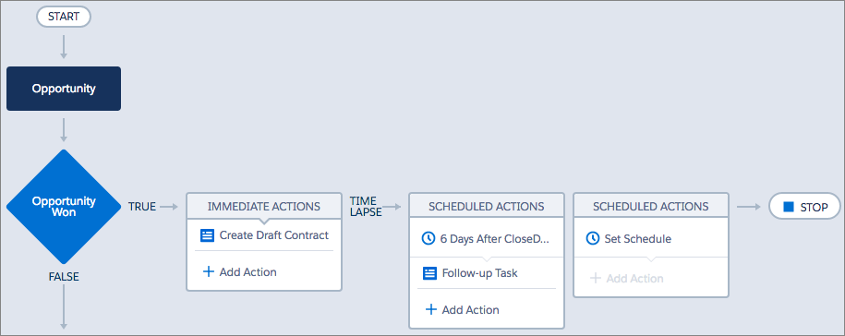

**Process Builder** is a newer tool for admins which is even more powerful. In addition to everything a workflow can do (except for sending outbound messages), you can:

* Create a record (not just Tasks!)
* Update related records
* Launch a Quick Action
* Post to Chatter
* Launch a Flow
* Call Apex code
* Submit for approval
* Invoke another process

Process Builder also extends upon the things that workflow does. For updating related records, Process Builder can update any field on any related record, where Workflow can only update some fields on a parent record of a Master-Detail relationship. Process Builder can also update *multiple* related records in a situation when all of a record’s child records need the same update.

Also, Process Builder finally gives admins the ability to set the exact order of operations, whereas with Workflow we had no control. No more complex workarounds to be able to ensure things happen in a certain order!

Since Process Builder also has the ability to configure multiple if-then conditions in one Process rather than separate Workflow rules, it helps new admins and admins who inherit orgs visualize the business processes with its sleek visual interface.

Process Builder has versions, so you can retain deactivated Processes. This can be very helpful if you realize something isn’t working and want to look back to what was happening before.

## The Future of Process Builder & Workflow Rules

Declarative tools such as Workflow & Process Builder have been an Admin’s best friend for many years, but this may change in the near future…

Salesforce has [publically](https://architect.salesforce.com/design/decision-guides/trigger-automation/)stated that they will no longer be enhancing Workflow rules or Process Builder. If you are using these tools, don’t worry though, they aren’t going anywhere and Salesforce will continue to support them.

While Process Builder has been the poster child of declarative automation for many years, Salesforce has been updating the functionality less, in favor of Flow.

If you are unfamiliar with [Flow](https://www.salesforceben.com/introduction-salesforce-flow/), I highly recommend you check out this extremely powerful tool that is comparable to how Apex code works, but with a point-and-click interface. If you are looking to future proof your skills, it looks like Flow is the future.

[Salesforce Flow](https://www.salesforceben.com/introduction-salesforce-flow/) is the most powerful automation tool that Admin’s have at their disposal. If a Salesforce automation tool reaches its limitations, you would usually turn to a Developer to implement Apex, but Flow’s comparably powerful. With Flow you can…

* Display data to your users with screen elements (Think a wizard style interface)
* Control logic by creating branches and looping over data sets.
* Lookup, create, update, or delete Salesforce records.

With these features, Flow works in a very similar way to how Developers code Apex, which gives you the power to create similar functionality.

Salesforce has now turned to Flow as their favorite automation tool to keep updated in each release, so get ahead of the curve and learn flow today!

**Profile**

* A profile is a group/collection of settings and permissions that define what a user can do in salesforce.
* A profile controls “Object permissions, Field permissions, User permissions, Tab settings, App settings, Apex class access, Visualforce page access, Page layouts, Record Types, Login hours & Login IP ranges.
* You can define profiles by user’s job function. For example System Administrator, Developer, Sales Representative.
* A profile can be assigned to many users, but user can be assigned single profile at atime.

Types of profiles in salesforce  
  1. **Standard profiles**:

* By default salesforce provide below standard profiles.
* We cannot deleted standard ones.
* Each of these standard one includes a default set of permissions for all of the standard objects available on the platform.

  2. **Custom Profiles**:

* Custom ones defined by us.
* They can be deleted if there are no users assigned with that particular one.

**Users**

* A user is anyone who logs in to Salesforce. Users are employees at your company, such as sales reps, managers, and IT specialists, who need access to the company's records.
* Every user in Salesforce has a user account. The user account identifies the user, and the user account settings determine what features and records the user can access.
* Each user account contains at least the following:  
  *Username  
  Email Address  
  User's First and Last Name  
  License  
  Profile  
  Role (optional)*
* efore I break down some use cases for record types, I thought it would be effective to start with how Salesforce explains what they are and what they do.  According to [Salesforce documentation](https://help.salesforce.com/articleView?id=customize_recordtype.htm&type=5):
* *“Record types let you offer different business processes, picklist values, and page layouts to different users. You might create record types to differentiate your regular sales deals from your professional services engagements, offering different picklist values for each. Or you might display different page layouts for your customer support cases versus your billing cases.”*
* In NPSP specifically, the Account object comes with two record types: Household Account and Organization. Having these two types of accounts as different record types makes it possible for different fields to be tracked on each. For instance, on a household account, you may want to see the number of household members rolled up in that account, whereas for an organization record, that field would not be needed because individuals would not be considered part of a household.
* Within that same record I could have one “Account Type” field with different options for each record type. Maybe for my organization records my options include a number of values like Corporation, Foundation, etc.  For my household account, I can choose to have far fewer options.

#### ****Page Layouts with Record Types****

* One of my favorite things about record types is the functionality it gives you with page layouts.  First of all, what’s a page layout? [Salesforce documentation](https://help.salesforce.com/articleView?id=customize_layout.htm&type=5) explains what page layouts do in the following way:
* *“Page layouts control the layout and organization of buttons, fields, s-controls, Visualforce, custom links, and related lists on object record pages. They also help determine which fields are visible, read only, and required. Use page layouts to customize the content of record pages for your users.”*
* In order to understand the difference between [salesforce.com](https://salesforce.com/) and [force.com](https://www.force.com/), one must understand the basic cloud computing concepts.
* Salesforce is a company and [salesforce.com](https://salesforce.com/) is a Customer Relationship Management (CRM) application developed based on Software as a Service (SaaS). [force.com](https://www.force.com/) is a platform that helps developers and business users to build powerful enterprise applications.

# What are Sandboxes in Salesforce?

[KeyNode Solutions](https://medium.com/@KeyNodeTeam?source=post_page-----8f632f5f4123-----------------------------------)

[KeyNode Solutions](https://medium.com/@KeyNodeTeam?source=post_page-----8f632f5f4123-----------------------------------)

[Nov 19, 2019·4 min read](https://medium.com/@KeyNodeTeam/what-are-sandboxes-in-salesforce-8f632f5f4123?source=post_page-----8f632f5f4123-----------------------------------)

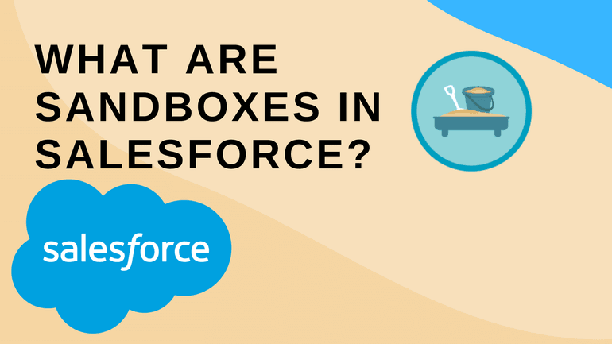

Salesforce sandboxes are copies of your Production environment. A sandbox contains all the configuration, customization, apps and code (known as **metadata**) that you have made to your Production environment (where users login and work every day). Some sandbox types can even contain all or some of your production data too.

The benefit of a Sandbox is you can do anything you like in there without any risk of harm to the configuration or data contained in your Production environment.

# How can I use these sandboxes?

The uses of sandboxes really depend on your needs but common uses are as follows:

**Training** — Start your new users off in a safe environment where they can practise without the risk of making mistakes, clicking the wrong button or entering incorrect data. It takes the stress out of the training process and users can create their own records, make mistakes and learn from them without any risk to your production environment. If your Salesforce licence type provides partial copy of full copy sandboxes then these are ideal for training as you will then have a copy of real data that your users can experiment with.

**Development** — If you have some developers (or awesome admins) that need to make changes and improvements to the production environment, these changes should be done in a sandbox first and later copied to production when completed. In fact, there may be many sandboxes used in the development of new features — development, integration testing, quality assurance and user acceptance testing. As the new feature is developed and tested, it is moved from one environment to the next until it is finally ready for released to production.

**Experimenting** — What if you see a new app in the AppExchange and want to try it out and see what it can do for your business? A sandbox is the perfect place to do this. Most AppExchange apps have free editions that can be installed into a sandbox for exactly this purpose. If you want to try to build a new automation, test a new way of doing something or create a proof of concept to demonstrate a feature — a sandbox is the perfect solution.

**Learning** — If you have a new staff member who is keen to learn some Salesforce administration and development then insist they do this in their own sandbox where they cannot do any harm.

# How many Sandboxes do I have?

This depends on your type of Salesforce licence:

https://miro.medium.com/max/60/0*5P5hkjxygl84ofUs.png?q=20

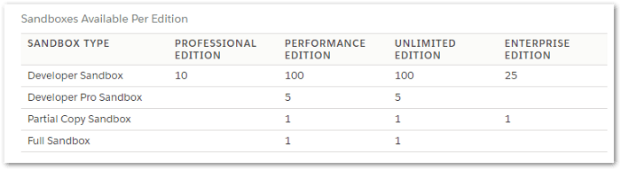

Note: If you are using a free Developer Salesforce org, it already is a sandbox so the sandbox functionality described here does not apply, you cannot create a sandbox within a sandbox environment.

# What are the different Sandbox types?

There are four different types of sandboxes with different features.

The **refresh interval** means how frequently you can overwrite it with a new copy of the production environment. The Developer and Developer Pro sandboxes could be refreshed every day if you want. The partial copy only every 5 days and the full copy once every 29 days.

**Storage limits** are in two parts — data storage (your customer records) and file storage (additional files that have been uploaded and related to records). While the data storage in the Developer and Developer Pro sandboxes are relatively small, they don’t come pre-populated with any data so they are usually adequate for your developers and their unit testing.

The partial copy and full copy do contain a copy of the data (customer records) from your production environment. The partial copy contains up to 5 GB of your production data and the full copy, as the name suggests is a complete copy of all the data in your production environment.

https://miro.medium.com/max/60/0*fGdjjhR5bG6Yq-S2.png?q=20

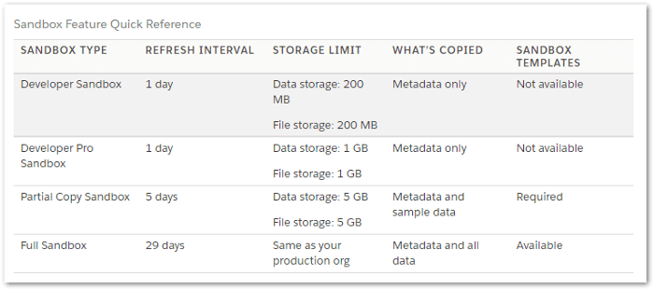

# How do I create a sandbox?

This is something that your Salesforce Administrator needs to create, but it is quick and easy, just a few clicks to create them. The developer sandboxes only take a few minutes to create but the partial copy and full copy can take hours or even days (as there can be a lot of data to duplicate).

https://miro.medium.com/max/60/0*IWPddlAti9HSMzSR.png?q=20

